**DBE project report**

*Name of the solution*

Names of team members

*[Insert client logo somewhere on this page]*

ddddd

*This document is intended as a summary of the DBE project to support the evaluation. All items (except for the executive summary) should have been created during the project.*

# Summary

[Present your challenge, your client and your solution in full. Limit your introduction **to 200 words**.]

# Personal description

[Introduce yourself, who are you and what previous experience do you have in project work?]

# DBE project open haste and key problem

[Briefly describe the challenge. What are the key elements of the problem?]

# Benchmarking analysis

[Describe and create a table comparing existing solutions and the data you have obtained from them. Provide links and references to literature, presentations, websites and/or videos on existing solutions. Feel free to include images of existing solutions].

|  |  |  |  |  |
| --- | --- | --- | --- | --- |
|  | **Features** | **Strengths** | **Weaknesses** | **Opit** |
| Solution 1 |  |  |  |  |
| Solution 2 |  |  |  |  |
| Solution 3 |  |  |  |  |
| Solution 4 |  |  |  |  |

An example of a comparative analysis table of solutions.

# Users or customers, key people in the project

[Who are the third, second and primary stakeholders of your solution/system? For whom is the solution created?]

# User research

[Describe the implementation of the user research]

|  |  |
| --- | --- |
| OBJECTIVES | * Describe the objectives of your research * List the methods used and explain why you used them |
| PARTICIPANTS | * Participants are the primary users of the system or product. * Describe the number of participants and demographic data * Why these participants were selected |
| PROGRAMME | * Describe the sequence of actions taken by the participants in the user survey in chronological order. |
| DATA COLLECTION | * Describe the content of the data collection methods (e.g. questions used in interviews / type and focus of observation / questions and scales of questionnaires). |
| DEVICES | * Describe how you stored user survey data (e.g. audio/video recordings, pictures, observer/interviewer notes). |

# Defining the problem

#### How might we...?

[Which *"how might we*" question do you focus on and why?]

# Prototypes and their testing

[Attach pictures of your prototypes.]

#### The story of the prototype

[Describe the prototype and the people and needs it addresses.]

#### We believed that ...

[What was the hypothesis you wanted to test with this prototype?]

#### We discovered that...

[What did you see/hear from your test users when you presented the prototype to them? What feedback did you receive during testing?]

#### We learned that...

[What did you learn from the feedback? What did you decide to change as a result? ]

# Solution

[Share your final concept and explain the originality, sustainability, feasibility, desirability and viability of the solution. Provide more information on your vision for the future development of the solution]]

## Originality

[How original is your solution compared to existing solutions? For example, does your solution have some features that are not present in existing solutions? Is your solution new in Kanta-Häme, Finland, Europe or the world?]].

## Sustainable development

[Describe how your solution supports [the three pillars of sustainable development](https://youtu.be/ijSSe66865w): economic, environmental and social, and helps achieve the UN Sustainable Development Goals: [https://sdgs.](https://sdgs.un.org/goals)un.org/goals.]]

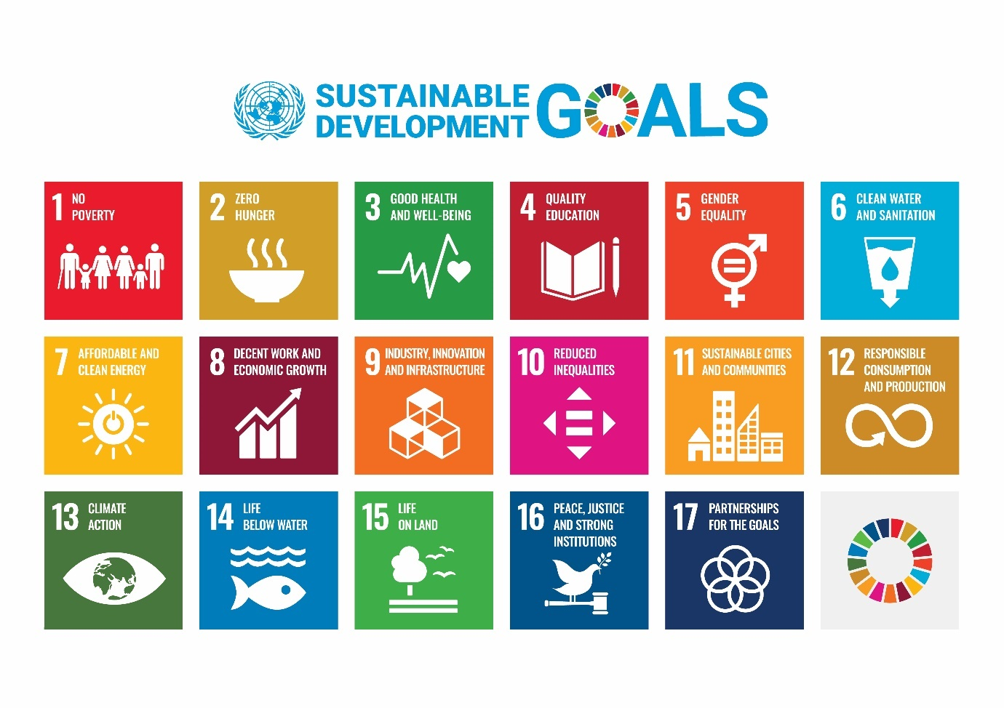

## Feasibility

[How feasible is the solution. You can also use NASA's Technology Readiness Level to describe the feasibility of your solution: [https:](https://www.nasa.gov/directorates/heo/scan/engineering/technology/technology_readiness_level)//www.nasa.gov/directorates/heo/scan/engineering/technology/technology_readiness_level].

## Desirability

[How desirable is the solution for users? Insert the results of the user testing here. What did users say about your solution? How does your solution meet their needs? How likely are users to use your solution?]

## Viability

[How feasible is your solution? What will it cost to create, maintain, move/transfer, reuse? How do climate and weather conditions affect the feasibility and cost of your solution?].

## Visio

## [What are the future development opportunities?]

# The main lessons

[Tell us what you learned during the project. Reflect in relation to innovation competences. What skills did you develop during the project? What did you learn about the topic of the module?]